**[Day 14 (15th Feb'22) - Exception Handling](https://learnifyme.ialabs.co.in/course/view.php?id=19" \l "section-14)**

**Java batch 1**

**Khushi Agrawal**

**Session 1**

1. create a class and with divide two numbers by using Scanner class.(z=a/b).without try catch

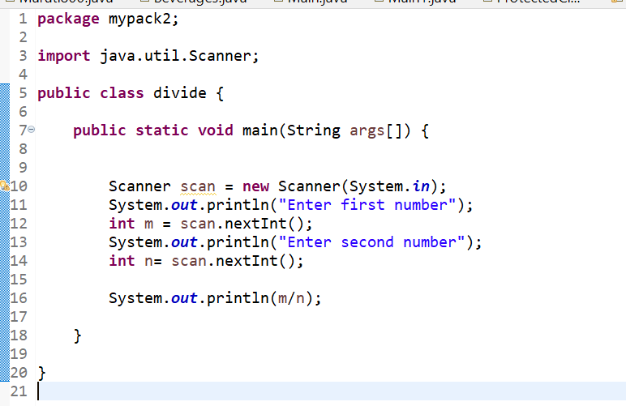

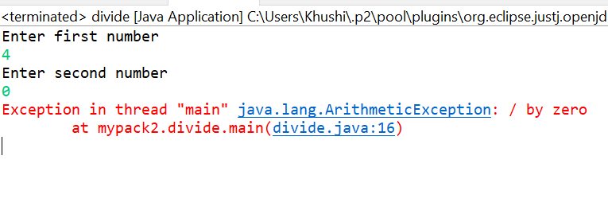

1. create a class and take the input from by using scanner class, as a end user take two numbers with division and observe which type of exception raised. and apply try catch blocks

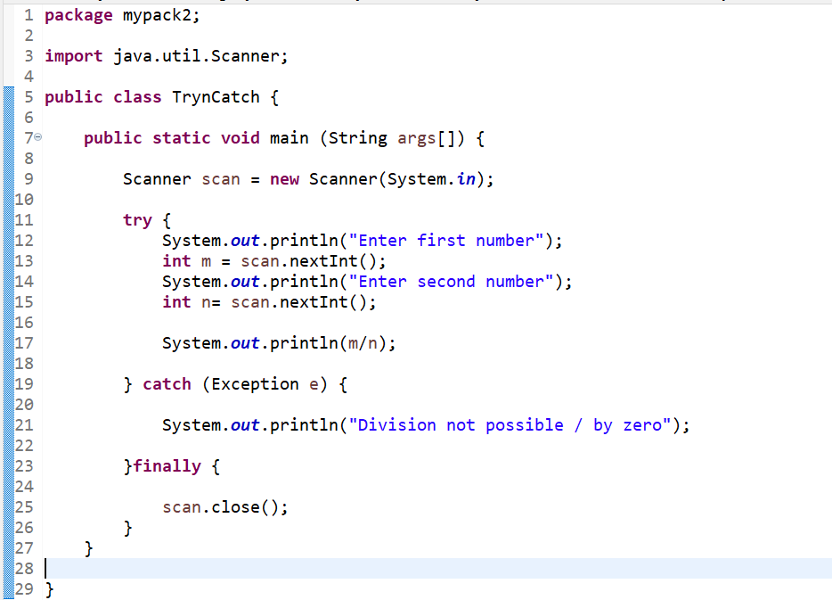

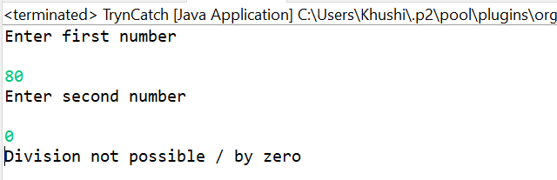

1. Create a class with single try multi catch blocks.

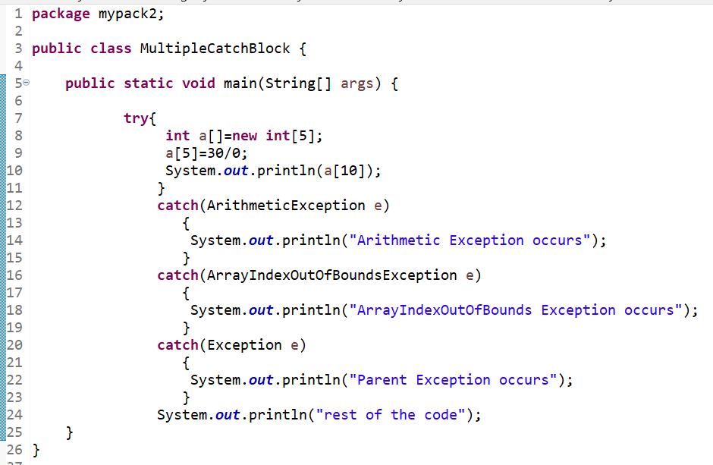

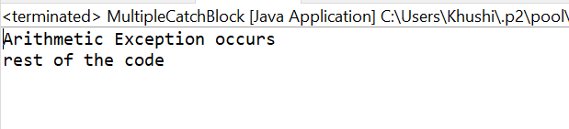

**Session 2**

1. create a class with user defined exceptions.

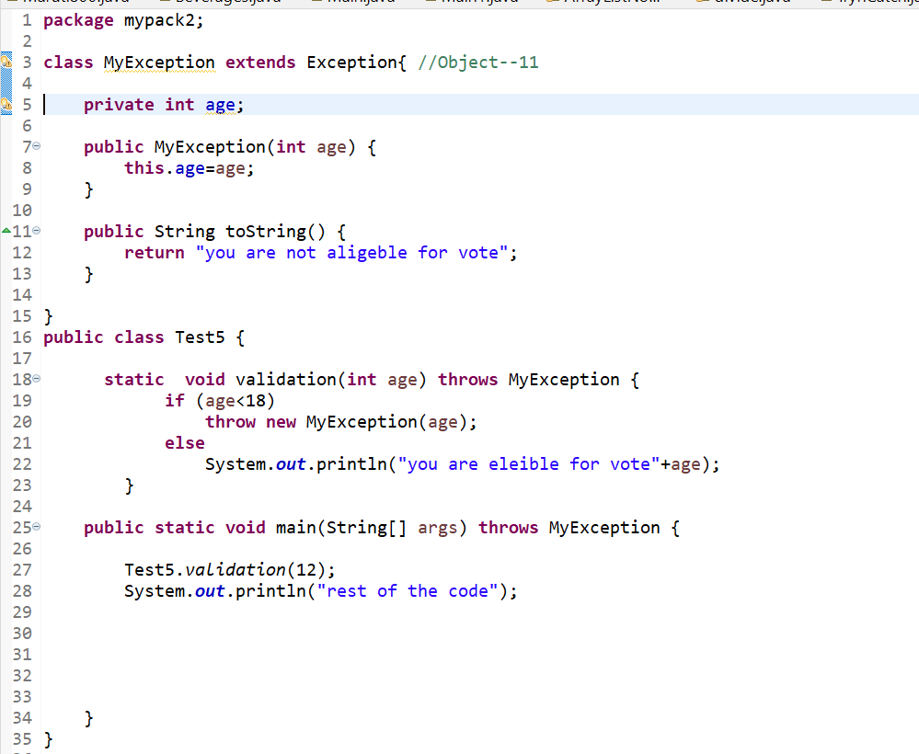

1. create a class with Marks, and valid Marks method, give some number marks are less than he/she fails otherwise pass by using throw keyword.

